GAME DESIGN Report C17870 TRUMP ESCAPE/ LAND OF THE FREE THOMAS SIMMONS K1906250

Module Leaders: Hope Caton & Jarek Francik

# Contents:

Contents: 2

Introduction 3

Ideas: 3

Aims: 3

Game Origins: 4

My Version: 4

Inspiration from games & events 5

Evolution of design 5

Outcome 5

What I have learned/ reflection of process 5

Future Development 5

Conclusion 5

References 5

# Introduction

This report is going to be about the origins and development of my game Trump Escape/ Land of the Free. Land of the free is a 3rd person role playing game at its core but also a game for every category of player. The four main categories of player fun are hard who are after personal goals and achievements, serious who are after excitement, easy who are after curiosity and surprise and people who are after amusement **(link 1).** I know it is very hard to include all these types of players into one game and do so successfully so I made it my aim to at least try to do so. The actions I will try to achieve from the players are goals achieving and strategy from hard fun players, exploration and creativity with easy players, collection and repetition with serious players and completion with people players **(Link 1).**

In this report I will be talking about the origins of this game idea and how I developed it, my aims and ideas after the origins game build, what inspired me to create this game and mechanics I liked in previous games which I want to implement, the evolution of the current game build and how I got there, the outcome of the most recent build of the game and finally the future development ideas **(Link 2).** Whist my main aims is to create a game for everyone to enjoy I also have a lot of personal interest in the game idea of a strategic game based on American politics and what could happen. The characters are also real people and follow what they have achieved and how they have disappointed the people around the world.

# Ideas:

My game idea is a game relating to current American politics, especially towards the actions on Donald Trump and his rule from 2016 to the present. This is a theme I have always been interested in and in my opinion make a great unique game genre. I researched into some of the main news stories towards American politics, how Trump has been involved and the consequences of every person or candidates actions. The player will be in the game world playing as Donald Trump during the time of decline for himself and American politics. His goal in the game world is to retake power in America and destroy anyone who’s in his way.

# Aims:

I am targeting the age group of 16 and above due to the high level of violence, moderate use of bad language, references towards discrimination and drug usage but due to the characters involved, the theme and storyline leaning towards fantasy the game shouldn’t be rated 18. My target market are players of all categories they partly or fully full into **(Link 1).** Players who are into communication towards allies and enemies who also love to complete games are “people players”, players who are into achievements within games and are strategic towards gameplay are “hard players”, players who are into exploring worlds and are creative are “easy players” and finally players who like replay ability and collection are “serious players”.

My aim for this game is to try and create a storyline, features and characters suitable for all these player categories by bringing in skill and challenge for hard players, expectation and storyline for easy players, relaxation and excitement from serious players and playing in groups or friends whist playing for people players. This is will a grave challenge but I think it’s possible with this game theme and style of play to attract all these players to my game.

# Game Origins:

This game was originally created as a two player board game called Hnefatafl **(link 3),** better known as Tablut **(Link 4)** which is a Viking game based game in the early medieval period or dark ages. The board is 11x11 square table where one side has twenty four pieces and another had twelve and one king, the rules and board itself on figure () are below:

* Aim of the team with twenty four pieces is to capture the King
* Aim of the team with twelve pieces is to help the king reach a corner of the board
* Movement is one square horizontally or vertically, no diagonal
* No piece can rest on the refuge or king starting squares
* Take pieces by squashing opponents pieces between two of your own
* If a legal move cannot be taken on their turn the game is a draw
* To take the king he has to be surrounded on all four sides
* Win condition is whether the king is captured or escapes.

## My Version:

I was tasked in a past assignment to iterate this game to help improve gameplay as well as keep the players engaged whist preventing any dominant strategy being made. I made several new rules on top of the current ones to do so, they are listed below:

* In the grey boundary on the board the king can move two spaces or one space diagonally across the board
* Can be player by 2-5 players
* Capturing pieces sends them to the red zones chosen by capturer on the map
* Turn the alliance of the piece giving control to another player
* Increased escape zones for king piece due to advantage of numbers by attackers
* Attacking players can work together or by themselves causing fights amongst each other

With these new rules my players where far more engaged to the game and lots of new strategies where formed. With the completion of this game when 5 players where playing and some teamed up with others whist some fought each other as well as trying to kill the king, the board design is shown below in figure (). This gave me the idea to implement politics into the game, specifically the America 2016 elections between Trump, Clinton, Sanders and other minor candidates **(link 5).** This was a great theme towards the players and as a result “Trump Escape” was formed.

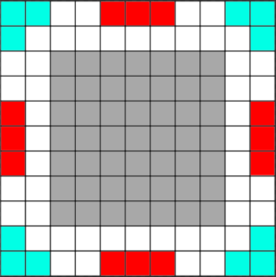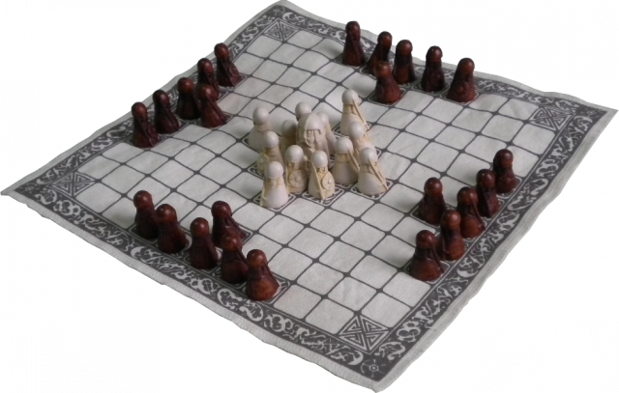

# What inspired me?

During the development of my game from the origins stage I played a lot of games and genres, some of which I completed and others got boring so what I will try to do is merge all the good parts of each game and its genre together to create a game where it’s for every type of player.

## Tom Clancy Games Storytelling:

I have always been a fan of Tom Clancy games, my three favourite game series of his are Ghost Recon, The Division and Rainbow and The Division is my favourite. This is due to the storyline and gameplay of this series. With the exception of the Rainbow series these games are 3rd person based where the player is either alone playing as a super soldier saving America from civil war caused by a plague called “dollar” in The Division or in a group of four trying to take down drug cartels or dictators in Ghost Recon. These stories are vast and lengthy but for a time can keep the player playing.

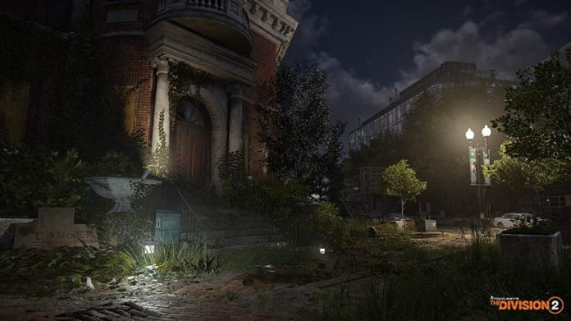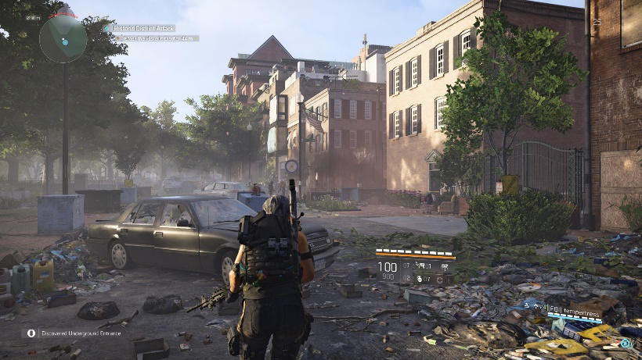Both these game series have a lot of side missions and activities the players can complete for extra rewards and experience to level up there character. Some of the mission relates to the main story missions, some are given to the player through discovery/ free roam and other are earned but completing other missions or completing tasks set by allies. All of these methods keep the players engaged to the game as well as the storyline. Below in figures () the scenery and player view of these games **(Link 6).**

## GTA V customisation options

* Farming Simulator customisation simplicity
* HALO 3 ODST collectable discovery system
* NFS Carbon territory gaining and rewards system
* Recent political events
* Personal discovery of gap in the market

# Evolution of design

* Feedback from interim presentation
* One player option to three
* Summary of storyline for all three characters
* Progression chart development
* Characters goals/ endgames
* Icons and what they represent (reference division 2 images)
* 3D models created and downloaded (reference downloaded models, YouTube videos)
* Logos and map and what they represent (reference trump and Clinton images)
* Development of design prototype (YouTube videos)
* Discovery of Adobe Fuse and how to use it

# Outcome

* Complete 3d models which can be used
* Character creation skills from fuse
* Story telling skills
* Character customisation screens
* Reaction from fellow students and lecturers

# What I have learned/ reflection of process

* How to use Autodesk Maya more effectively
* Where I can get detailed models to use
* How to use adobe fuse
* How to use Visio to create charts effectively.

# Future Development

# Conclusion

# References

1. <https://www.nicolelazzaro.com/the4-keys-to-fun/>
2. <https://www.monash.edu/rlo/assignment-samples/engineering/eng-writing-technical-reports/introduction>
3. <http://www.cyningstan.com/game/221/hnefatafl>
4. <https://healthy.uwaterloo.ca/museum/VirtualExhibits/Vikings/Tafl/viking/index.html>
5. <https://www.nytimes.com/interactive/2016/us/elections/2016-presidential-candidates.html>
6. <https://www.gamespew.com/2019/02/the-division-2s-new-scenery-is-enough-to-draw-me-back-in/>